Constaint Satisfication Problem
- An CSP is defined by three components:
+ Variables (V): The entities that need vakues (e.g, regions on a map) => {X₁, X₂….X_{n}}
+ Domains (D): The set of possible values for each variable (e.g, {Red, Green, Blue}) => {D₁, D_{2,}….D_{n}}
+ Constraints ©: Rules that specify which combinations of values are allowed (e.g, neighboring regions must have different colos)
- For example:
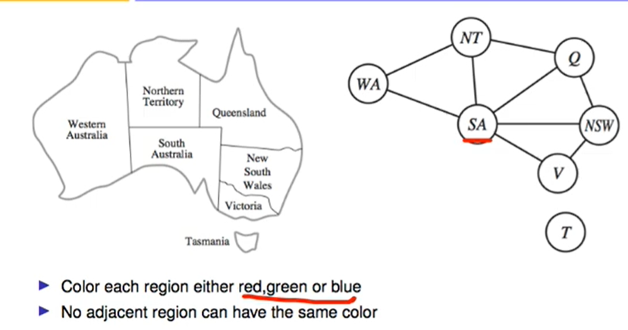
=> Variables: X = {SA, WA, NT, Q, NSW, V, T}
=> Domains: D = {red, green, blue} foreach X_{i} ϵ X
=> Constraints: C = {(∀X_{i,} X_{j} such that X_{i} touches X_{j}), (Color(X_{i}) ≠ Color(X_{j}))}
- Kinds of Contraints:
+ Unary: Involve a single variable (SA ≠ green)
+ Binary: Involve a pair of variables( SA ≠ WA)
+ Higher Order: Involve 3 or more (Cryptarithmetic’s)
- Backtracking Search:basic informed algorithm for solving CSPs. It is essentially a Depth-First Search (DFS) that chooses values for one variable at a time and "backtracks" when a variable has no legal values left to assign.
+ Core Machenism:
* Selection: Pick an unassigned variale from set V
* Assignment: Try assigning a vaule from domain D
* Constraint Check: Immediately check if the current assignment violates any constraints C. If consistent, proceed to the next unassigned value. If no, Abandon that branch (don't go deeper) and try a different value for the current variable.
* Backtrack: If all values in the domain fail, return to the previous node (the previous variable), undo its assignment, and try the next available option there
- Optimize Heuristics:
+ Variable Selection: ‘Which variable should be assigned next?’: The philosophy here is Fail-fast. If a branch is going to lead to a dead end, we want to discover that immediately rather than wasting time going deeper into the tree.
* Minimum Remaining Values (MRV): Choose the variable with the fewest legal values left in its domain.
* Degree Heuristic: Choose the variable involved in the largest number of constraints with other unassigned variables.
+ Variable Selection: "In what order should its values be tried?": The philosophy here is Succeed-fast. Once we have picked a "difficult" variable, we want to try the value most likely to lead to a solution on the first try.
* Least Constraining Value (LCV): Choose the value that rules out the fewest choices for neighboring unassigned variables.
+ Inference / Constraint Propagation: "Look-ahead": The philosophy here is Pruning. We use the logic of constraints to eliminate impossible values before we even reach that part of the search.
* Forward Checking: Whenever variable X is assigned, look at all unassigned variables Y connected to X and delete any values from Y’s domain that conflict with X’s value.
* Arc Consistency (AC-3): A more advanced look-ahead that ensures every directed arc $(X, Y)$ is consistent.
- Operating Philosophy: "Repairing instead of Building" => Unlike Backtracking, which builds a solution step-by-step, Local Search starts with a "broken" state and fixes it.
* Initialization: Assign a value to every variable simultaneously (often randomly).
* Iteration: At each step, the algorithm selects a conflicted variable and changes its value to move closer to a consistent state
* Termination: The search stops when all constraints are satisfied or a pre-defined limit of steps is reached.
- The Min-Max Algorithm: This is the most common Local Search heuristic for CSPs mentioned in your materials. Its mechanism is simple
* Select: Choose a variable that is currently involved in a conflict.
* Evaluate: Test all possible values for that variable within its domain.
* Assign: Change the variable's value to the one that results in the minimum number of conflicts with all other variables.

